

# **[Donate to New Roots](https://newroots.org/donate-today/)**

We’re counting on support from friends like you to keep growing our community-powered food justice movement.



**We are proud to announce our first-ever annual campaign! Sign up now to pledge a recurring monthly donation today in any amount; when we all pitch in, amazing things happen!**

# **[Fresh Stop Markets](https://newroots.org/fresh-stop-markets/)**

**Our growing season has come to a close, but the 2019 organizing season is just beginning.**

Check out your local FSM here, and get to know the dedicated volunteer leaders who make it happen…***then, contact us to get involved today!***

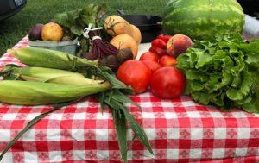

# **Our Mission and Vision**

### **Just like air & water, everyone has a right to fresh food. New Roots ignites community power for fresh food access.**

In a nutshell, **we are uniting communities to spread food justice.** Seventeen(!) Fresh Stop Markets will operate under New Roots’ umbrella during the 2018 growing season. The main fruit of our labor are the Fresh Stop Markets — farm-fresh food markets that pop up at local churches, community centers, and even in the courtyards of local businesses—in fresh food insecure neighborhoods. The food has been paid for in advance so that farmers don’t face the same degree of risk as they do with a standard farmers’ market. Every Market has a chef cooking up the very same vegetables and fruits that shareholders bring home. Our *Beet Beat* newsletter has recipes and stories from Fresh Stop Markets around the state.

We also facilitate other powerful food justice initiatives such as the [Makeba Lee Fund](https://newroots.org/makeba-lee-fund/), the [Fresh Stop Training Institute](https://newroots.org/food-justice-workshops-fresh-stop-training-institute/), and the [Gendler Grapevine Interfaith Food Justice](https://newroots.org/gendler-grapevine-interfaith-food-justice/), all of which are tied to our community-run Fresh Stop Markets.

***Our office is adjacent to Louisville gem*** [***The Table Café***](http://www.tablecafe.org/) ***in vibrant Portland. We can’t say enough great things about these dear friends in local food justice! The Table is a non-profit, social entrepreneurship that serves locally grown, fresh food and operates under a pay-what-you-can model. They provide creative payment solutions for all so that everyone can get a seat The Table!***

**The Table Café serves lunch Monday – Friday, 11:00 AM – 3:00 PM; drop in on us and say hello after your next visit!**

**1800 Portland Avenue**

**Louisville, KY 40203**

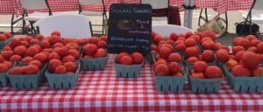

### **Get ready for the action!**



Click [here](https://newroots.org/calendar/) for the current New Roots calendar.

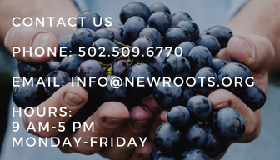

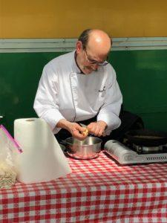

## [**COMING SOON! The Root Cellar:**](https://newroots.org/our-blogs/)***[Archives](https://newroots.org/our-blogs/)***

*Storing news, recipes, and veggie tip sheets from last season’s Fresh Stop Markets.*

Did you miss an issue of the *Beet Beat* this year? Trying to recreate that AMAZING dish you sampled at a market? Seeking “best practices” to keep your veggies fresh at home? Not to worry – download a PDF from our archives.